決策科學Homework IV (Group8)

1. Use the Hooke-Jeeves algorithm to find the best Q, p, and expected profit

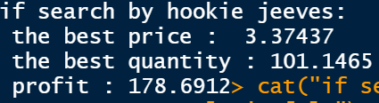

1. Use the genetic algorithm to find the best Q, p, and expected profit

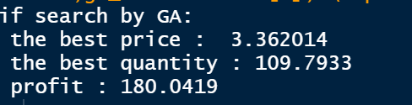

1. Which algorithm gives you the optimal decisions?

Genetic algorithm gives us the optimal decisions.

1. Repeat (a) - (c) by assuming ε follows an exponential distribution with mean 10

